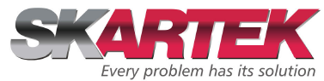

SUPPLIER CODE OF CONDUCT

 | Written by: | Approved by:
Work classification: | CEO Assistant | CEO
Date: | 18/02/2026 | 18/02/2026
Signature: | Andrea Lopatka | Christophe PAYON
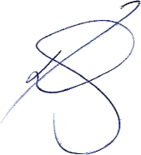
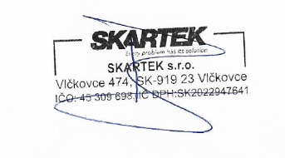

1. Purpose
SKARTEK is committed to responsible and sustainable business practices across its value chain.
We expect suppliers, subcontractors, and partners to uphold standards consistent with this Supplier Code of Conduct.
Compliance with this Code is a condition of doing business with SKARTEK.

2. Legal Compliance
Suppliers must comply with all applicable laws and regulations, including:
- Labor laws
- Environmental regulations
- Health and safety legislation
- Anti-corruption laws
- Trade and export controls

3. Human Rights & Labor Standards
Suppliers shall:
- Prohibit child labor and forced labor
- Respect freedom of association
- Prevent discrimination and harassment
- Provide safe and fair working conditions
- Ensure reasonable working hours
Suppliers are expected to uphold internationally recognized human rights standards.

4. Occupational Health & Safety
Suppliers must:
- Provide safe working environments
- Conduct risk assessments
- Provide appropriate training and protective equipment
- Investigate and record incidents

5. Environmental Responsibility
Suppliers are expected to:
- Comply with environmental legislation
- Reduce waste and emissions
- Manage hazardous substances responsibly
- Promote energy efficiency
- Where feasible, monitor greenhouse gas emissions

6. Business Ethics
Suppliers must:
- Prohibit bribery and corruption
- Avoid conflicts of interest
- Maintain accurate records
- Protect confidential information
- Compete fairly

7. Responsible Subcontracting
Suppliers shall ensure their subcontractors comply with similar standards.

8. Monitoring & Compliance
SKARTEK reserves the right to request evidence of compliance and may reassess supplier relationships in case of serious violations.

